Name: _______________________ ID: _______________________

**Analytical Chemistry II – Quiz (12th March, 2024)**

1) How does $v_{o}$ relate to $i_{i}$ in this circuit? Write down the formula.

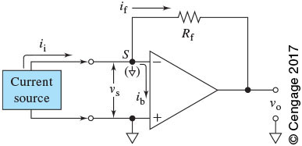

2) Write the equation of Beer’s Law. Explain all the symbols. Specify the units.

$$A=bc$$

*A* – absorbance (no unit)

*b* – optical pathlength (cm)

*ε* – molar absorptivity (L mol-1 cm-1)

*c* – concentration (mol L-1)